|  |
| --- |
| **Object Oriented Paradigm**  **Use Case Diagram /Object Model** |

|  |
| --- |
| **19CSE204** |

**DEGREE & BRANCH : BTech(CSE)**

**Duration : 1/2 hours**

|  |  |  |  |  |
| --- | --- | --- | --- | --- |
| **Q.**  **No.** | **Question** | **BTL/**  **Diffficulty level**  **(Easy/Medium/Difficult)** | **CO** |  |
| 1 | A person checks out a book by presenting the book and their library card to a clerk. The clerk scans the book and swipes the library card. The scan of a book reports the book's title, ISBN, publication date, and library order number. The person's library card contains the person's name and library identification number. The clerk then requests the library system check out the book. The check-out is approved if the person's library card is valid and they have not exceeded their check out limit. A check out record of the person's library card, book, and date that the book should be returned is made | Apply , DL -2 | **CO02** |  |
| 2. | Rani has been given the task of conducting a survey of sales clerks who will be using a new order-entry system being developed for a household products catalogue company. The goal of the survey is to identify the clerks’ opinions on the strengths and weaknesses of the current system. There are about 50 clerks who work in three different cities, so a survey seemed like an ideal way of gathering the needed information from the clerks. | Apply , DL -2 | **CO02** |  |

**Rubrics for Evaluation**

|  |  |  |  |
| --- | --- | --- | --- |
|  | **Good** | **Average** | **Need Improvement** |
| **Design(15)** | **12-15** | **8-11** | **0-6** |
| **Visualisation(15)** | **12-15** | **8-11** | **0-6** |

1.

A person checks out a book by presenting the book and their library card to a clerk. The clerk scans the book and swipes the library card. The scan of a book reports the book's title, ISBN, publication date, and library order number. The person's library card contains the person's name and library identification number. The clerk then requests the library system check out the book. The check-out is approved if the person's library card is valid and they have not exceeded their check out limit. A check out record of the person's library card, book, and date that the book should be returned is made

USE CASE DIAGRAM:

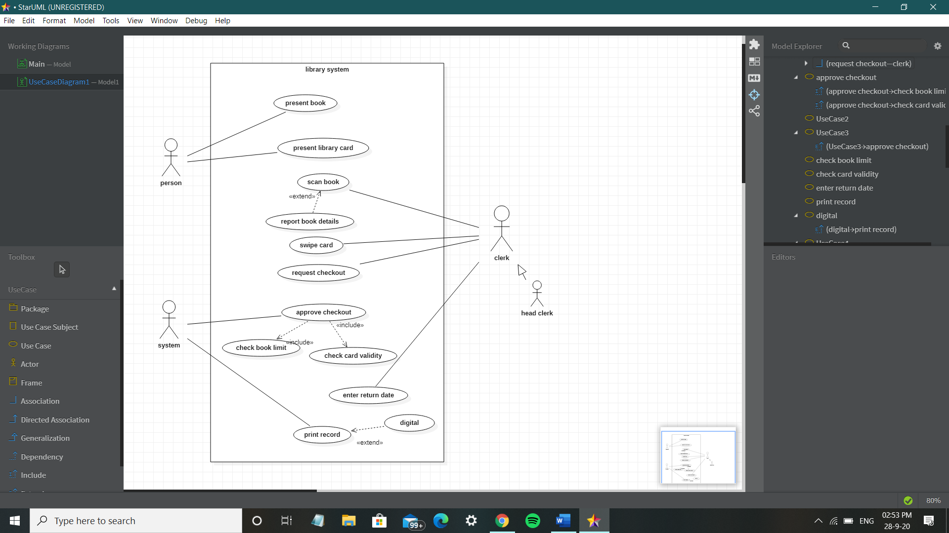

OBJECT MODEL DIAGRAM:

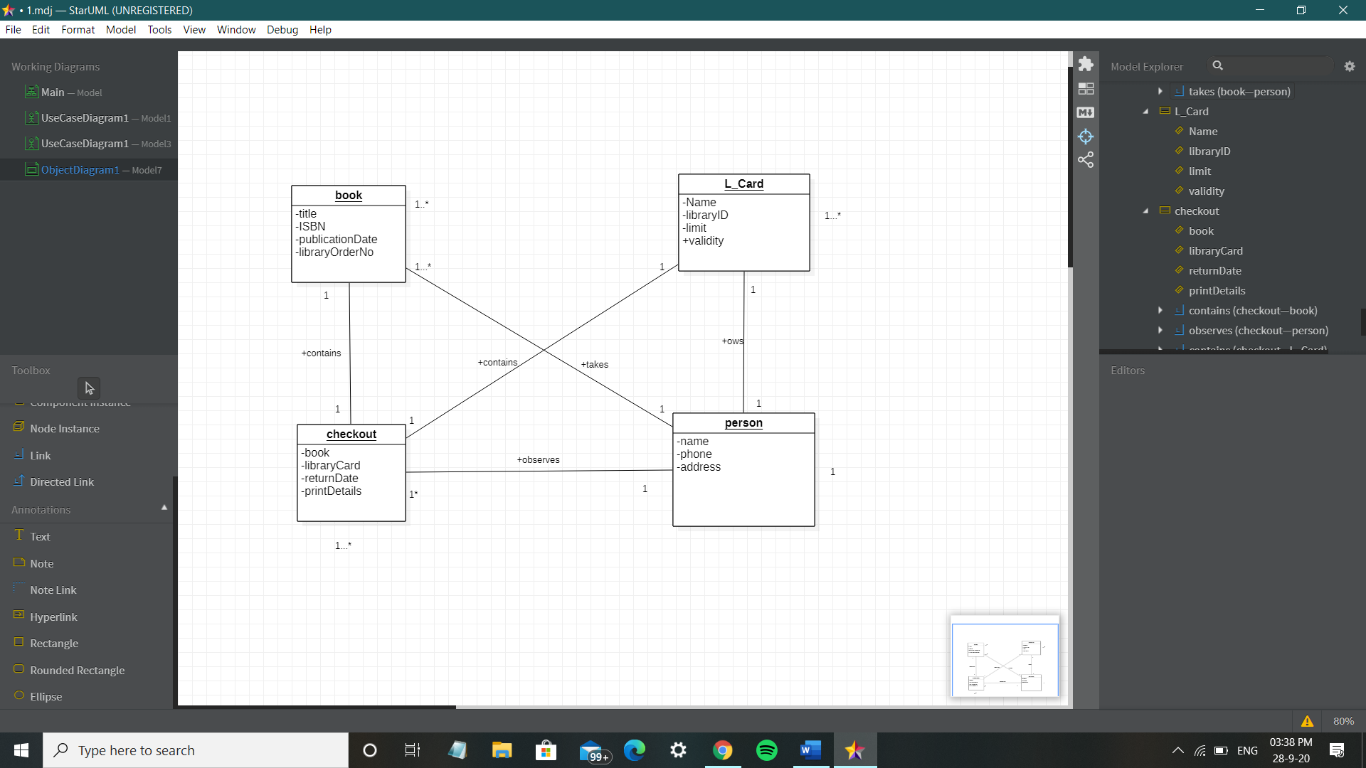

2.

Rani has been given the task of conducting a survey of sales clerks who will be using a new order-entry system being developed for a household products catalogue company. The goal of the survey is to identify the clerks’ opinions on the strengths and weaknesses of the current system. There are about 50 clerks who work in three different cities, so a survey seemed like an ideal way of gathering the needed information from the clerks.

USE CASE DIAGRAM:

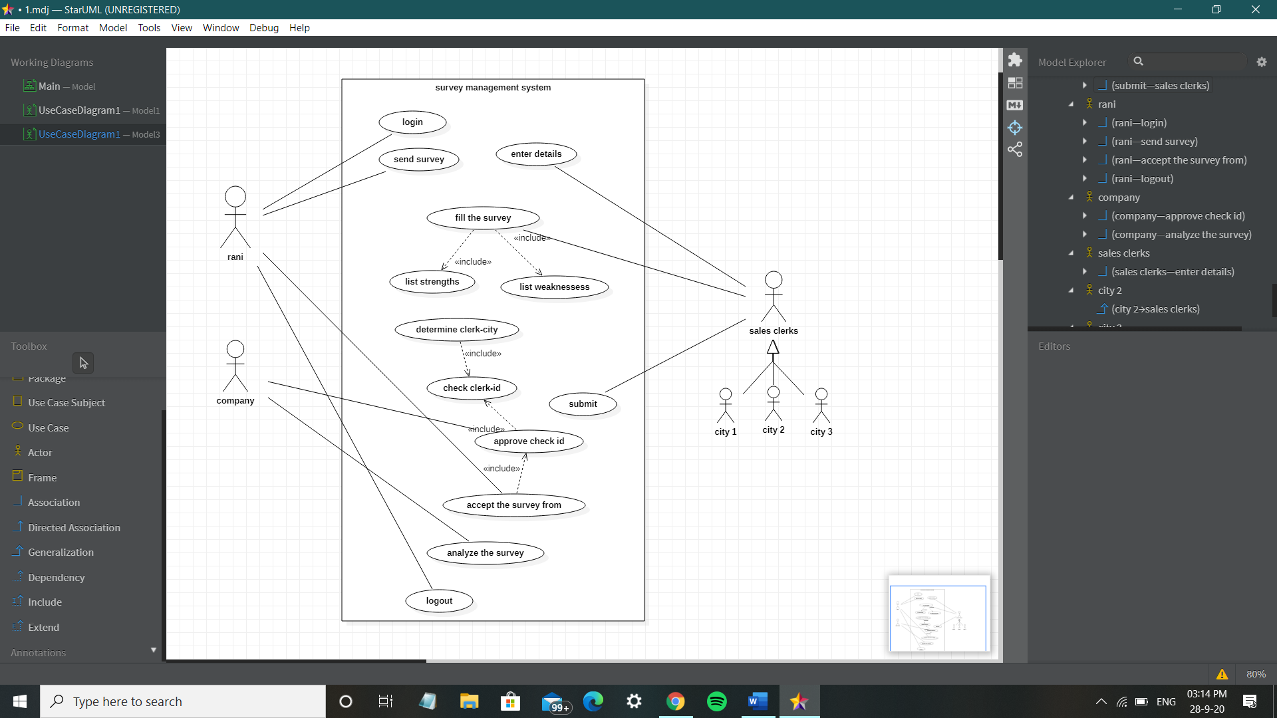

OBJECT MODEL DIAGRAM:

